**OIL REFINERY PROPOSAL**

BUSINESS CASE FOR NEW OIL REFINERY IN GHANA

June,2021

# **TABLE OF CONTENTS**

Executive Summary  3

Proposal Summary 7

Business Rationale 10

Competitive Analysis 17

Risk Analysis 18

Business Model 22

Estimated ROI 10

Exit Strategies 15

Glossary / Technical Terms 15

# **Executive Summary**

## XXXXXXXXXXXX

XXXX, specializes in energy processing. It is currently in preliminary stages to execute a $50m recycle plant the Western region of Ghana. The Cape Coast Waste to Energy Project will convert waste products into diesel fuel using breakthrough technology. The project will solve waste disposal issues and greatly improve the environment, whiles providing a valuable service to local authorities and a profitable operation for the company.

The company has also the capability of using mobile energy units such as the Mini-Refinery (developed by GCC) that uses a patented process to convert natural gas into a petroleum liquid.

As part of its innovative approach, the company is versatile in the use of energy conversion systems. The company is committed to environmental friendly processed and lower carbon foot print in its projects. For example, the company seeks to produce CNG which has a lower percentage of green-house gases compared to other fuels. This is value driver and guidance while it seeks to develop a $5bn oil refinery in Ghana, West Africa.

## Market DEMAND

There are significant factors driving the demand for an oil refinery in Ghana

* Aging national refinery (TOR) that runs the whole economy.
* Increasing petroleum and gas demand as national development projects are being executed country-wide. An example, is the one-district, one factory project (1D1F). With 260 districts, the energy demand is staggering.
* Trend of oil price increase to be curbed by government as it seeks to increase production locally though there is only one refinery in the country.
* Oil supply disruptions caused by civil war or unrest in the OPEC countries is a risk to world supply but an opportunity for Ghana (the list of major oil producers is shown below is a number being high risk countries such as Libya, Kuwait and Iraq.
* Global situation - Increasing world demand even though renewable energy is being encouraged, events such as impending space travel is increasing demand. Air travel is also increasing aviation fuel demand. Rapidly declining US energy production, though the US is probably the highest consumer. Basically, world demand still exceeds supply and the gap will not be closed per estimates for the future.

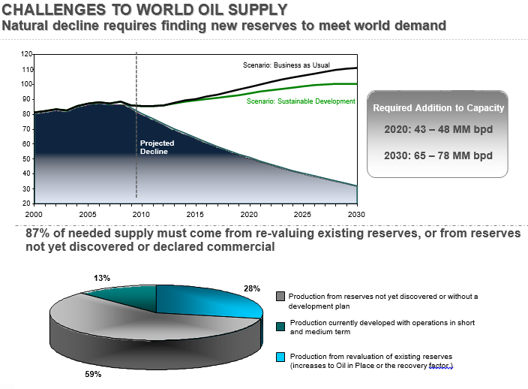

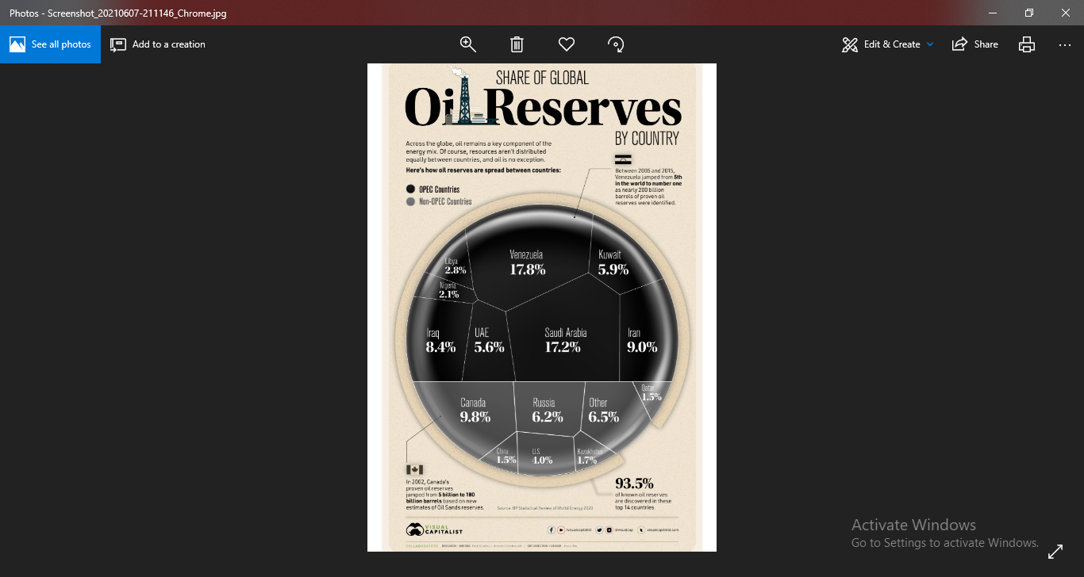

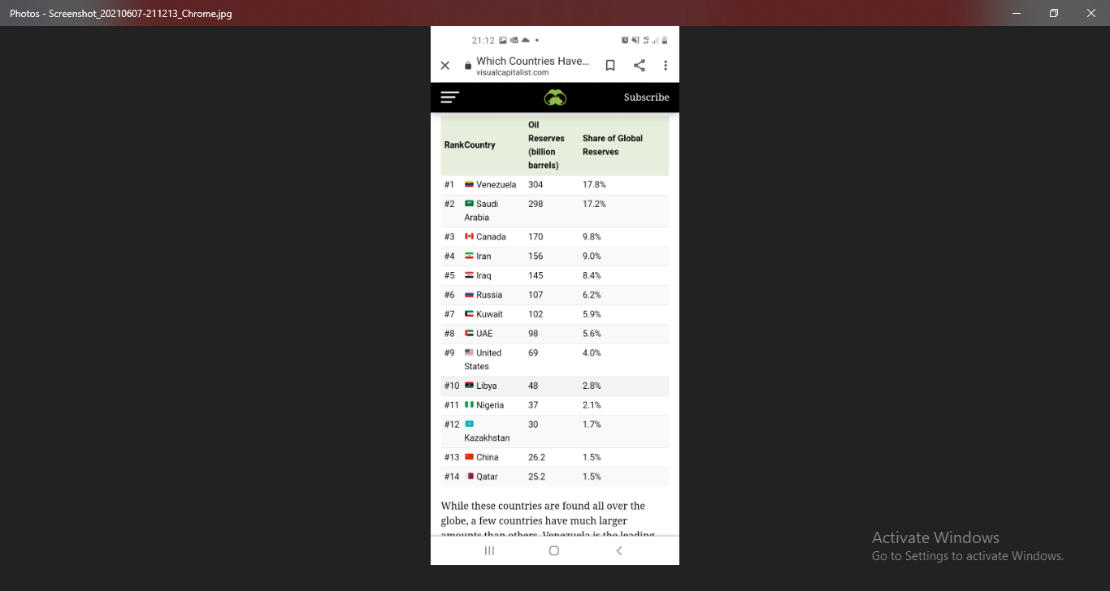

Ghana ranks 49th, producing 5.5% currently.

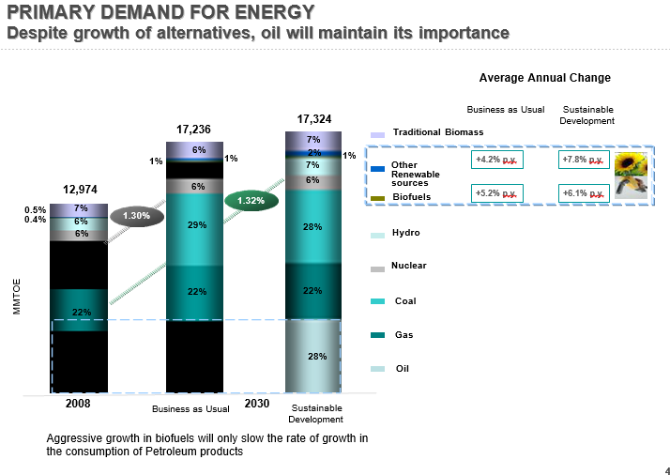

## THE TEAM – XXXXXX

The management and technical team have extensive experience (covering 10 to 30 years) in energy, petroleum transportation and storage expertise.

Together, the XXXXXX team has more than 80 years of combined industry experience in both operations and management.

The core team has the following unique and extensive experience;

* Manufacturing and Quality Control. Gauging / tank storage testing.
* Plant management, Petroleum economists, and Refinery operators.
* Fabrication of high-pressure vessels, controlling manifold and pumping systems.
* Estimators for top pressure value manufacturers from the oil industry.
* The design, materials & metallurgy, tolerances, ASME specifications, costs, for constructing equipment.
* Knowledge of pumps, motors, compressors, blowers, related electrical systems, piping, materials, performance and loading tolerances, OSHA safety standards and requirements.
* Pumpers and field superintendents of oil and gas production, for over twenty-five years.
* Extensive knowledge of well-site and field level production equipment, gas well operations and characteristics, and an in-depth understanding of the rules and regulations that cover oil and gas production operations.
* The company’s strength is found in the multi-talented and in-depth experience of its team and seeks to automate rather than be a labor-intensive company.
* Equipment maintenance, system analysis/evaluation and mechanical engineering.

## Financials

The significance of GCC’s business and technology is that the company projects cash flows in the first 2 years after operations have commenced, anticipates solid profits by the 5th year from then. The oil refinery, will only be th second in the country and so market penetration will not be a challenge though economically, development cost will be high due to construction from scratch. 8 year projections follow:

|  |  |  |  |  |  |  |  |  |
| --- | --- | --- | --- | --- | --- | --- | --- | --- |
| YEAR | 1 | 2 | 3 | 4 | 5 | 6 | 7 | 8 |
| EXPECTED CASH FROW $m | 0 | 100 | 150 | 175 | 200 | 250 | 275 | 300 |
| REPAYMENT $m | 0 | 0 | 0 | 0 | 0 | 250 | 250 | 250 |
| PROFIT $m | - | - | - | - | - | - | 25 | 50 |

Repayment: starting from year 5

Payback Period: Will be by year 24 (with Time Value of Money TVM)

Simple Payback Period: Will be by year 20

(assuming a $250m repayment per year without Time Value of Money TVM)

NPV / ROI

As shown above, the project has a positive NPV at a 4.99% rate. For a 100 year period, the refinery would have generated not less than $4.4bn in profits.

Based on this, two options are considered after a 100 years estimated useful life:

OPTION A - assume the refinery will be sold at the end of its life for $800m.

OPTION B - assume the refinery can be converted into a plant and used or sold to make a $1bn at the time.

|  |  |  |  |  |  |  |
| --- | --- | --- | --- | --- | --- | --- |
|  |  |  | TOTAL VALUE $bn | INTIAL TOTAL COST ($5bn at 3%) | NET PROFIT | ROI |
| OPTION A | Estimated salvage value if sold | $800m | 5.2 | 5.15 | 0.05 | 0.97% |
| OPTION B | Estimated Value if Converted into another Plant | $1bn | 5.4 | 5.15 | 0.25 | 4.85% |

In this case a pessimistic approach is being used because adverse variables like drops in fuel prices or competition reducing profits may occur over such a futuristic period. Hence the ROI here is one for the whole venture from the perspective of XXXXXXX for the 100 year period. The income gained after repayment is still discounted to 100 years.

This ‘stress test’ indicates that the ROI is still positive at the end of the useful life of the refinery. Note that the initial cost of $5.15bn is still deducted after repayment years in this analysis. This though not a conventional approach, implies that the refinery, has to be able to ‘work’ for the capital it has borrowed. In this sense, this analysis will be more useful to an investor which is how XXXXXX will approach its profit calculations.

From an optimistic approach, the ROI will be **24%** (1.27/5.15) at the end of 35 years which is a closer distance estimation.

Assumptions for the calculations:

Amount Required: $5bn ,

Interest Rate: 3%

$USD Inflation at 4.99% (TVM factor)

Cash flow increasing to $300m by year 8

Cash flow increasing to $700m by year 16

Cash flow staying at a minimum of $700m from year 16 to year 40.

# **PROPOSAL SUMMARY**

|  |  |
| --- | --- |
| **DEAL SNAP SHOT** | |
| REQUIREMENT / STRUCTURE OF PROJECTT | Requirement: $5,000,000,000 ($5bn) oil refinery  Estimated Construction period: 3 years  Estimated repayment period: 25 years  Off-takers: Local OMCs (Oil Marketing Companies), Chase Petroleum, Heavy manufacturing industries, mining and construction companies. |
| PPA STRUCTURE | It is expected that other investors especially from the Gulf region will show a 5-30% interest before construction completion. It will be 100% owned by XXXXXXXXXXX for the foreseeable future. |
| PPP/BOT/BT | PPP |
| LAND ACQUISITION DOCUMENTS | To be finalized and based on government approval.  Tentative locations are:  1 Takoradi -current location of new oil fields  2 Tema - current location of national crude oil storage sites and Tema Oil Refinery (TOR), the only oil refinery in Ghana  (Land size to be not less than 200 acres) |
| LAND VALUATION | To be completed |
| ENVIRONMENTAL PERMIT | Environmental Protection Agency (EPA) certificate to be acquired. |
| MARKET SHARE IN LOCAL MARKET | Minimum of 30% after operations commence |
| CAPACITY | To match and exceed TOR (Tema Oil Refinery) which has over a current capacity of over 6,000 metric tonnes per day (ie 45,000 bpd) |
| ESTIMATED INCOME SCHEDULE | Income schedule in relation to operations that will be affected of loan grant for expansion only:  Annually: Estimated not less than $250m after year 5  Estimated amount for repayment: $200m  Estimated amount for reserves: $50m |
| PROPOSED REPAYMENT SCHEDULE | $250 annually from year 8 to year 15  $700m annually from year 16 to year 24  Reserve ratio guideline – 20% of profit  Moratorium for construction period to be agreed on |
| COLLATERAL | Company assets to be registered in Joint names  Assignment of Receivables (AR) from Chase Petroleum |
| LOAN CONVENANTS | Stock level security  Appointment of Loan Issuing company as non-executive director |
| INDICATION OF GOING CONCERN | Foreign and local off-takers will always be available as TOR has been undersupplying for the past 58 years. |
|  |  |

# **BUSINESS RATIONALE**

WORLDWIDE PERSPECIVE

The worldwide oil production based on data from the oil producer supermajors; ExxonMobil, Shell, BP, Petrobras and Chevron indicate and intent to increase production to meet increase in demand.

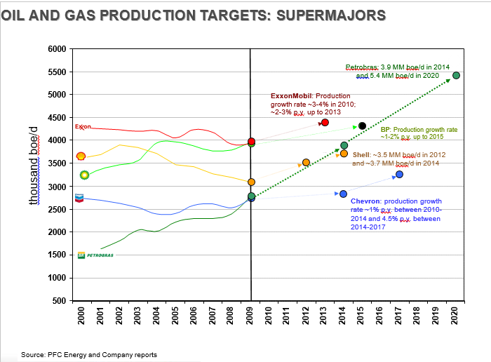

FEASIBILITY

Currently there is only one oil refinery in Ghana, the Tema Oil Refinery (TOR). Based on the fact that Net Imports of oil is still positive, it is a viable business to refine oil in Ghana. Exploration has commenced and so local supply has increased drastically putting pressure on TOR. Production was at 99,113 barrels per day (bpd) in 2016, 196,089 bpd in 2019 and estimated 500,000 bpd by 2025. These are production statistics from only the 3 current drilled oil fields Jubilee, Saltpond and Tweneboa Enyenra Ntomme oil fields.

Even though electricity has started trending as power for road vehicles, heavy machinery and aviation fuel will still use petroleum products for the foreseeable future.

Current exploration investments exceed $10bn as 450 to 550 million barrels are expected from new wells such as the Pecan and cape 3 points oil fields.

DIVERSIFICATION

XXXXXXX appreciates the risk of such a large investment in a single portfolio and so seek to diversify certain outlets and by products (such as LPG and LNG) which will enhance sales and mitigate against risks from unforeseen adverse events.

Examples are pre-ordered material for fertilizer industries, exporting the processed petroleum itself and well as the by-products from distillation which are in high demand. These products are used from car tyre, road construction to body and hair cream.

The spill over opportunities are countless however precautions will be taken to engage all the possible customers and obtain letters of intent (LOI) or permanent contracts to ensure purchase after production.

While the lifespan of the refinery will not have a challenge with regards to supply of raw oil or gas for the next 100 to 150 years, the diversification plan is important. One main reason is that the International Energy Agency (IEA) has a goal to make the world carbon neutral by 2050. This implies that it will discourage new explorations in the near future.

Having said that no new alternative has come close to replacing oil or gas fuel. Fossil fuel has remained above 32% of the world’s source of energy from 1980 to 2018. Current oil reserves will continue to be tapped for the 906 years per statistics.

# RISK ANALYSIS

# Venture & Investment Risk

The biggest risk associated with investing in GCC is beta testing might prove the technology needs further work, the catalyst needs modification and actual field operations may not meet the assumed economical benefit levels anticipated. Each could result in additional time or funding needs and ultimately result in lower than projected revenues and earnings potential.

|  |  |  |
| --- | --- | --- |
| **Terms** |  | |
| Investment Funds Sought: |  | $5 bn |
| Equity Stake in Gas Conversion Company: |  | 25% |
| Anticipated/Applied Funding Opportunities: | Government Grants | $ 150,000 |
|  | State Awards | $ 100,000 |
| Total: |  | $ 750,000 |

|  |  |
| --- | --- |
| RISKS / MITIGANTS | PERFORMANCE RISK  Off-taker renewal agreements to be established  OMC - customer purchase intent agreements will be put in place in advance before construction is complete.  OPERATIONAL RISK  Insurance of company and premises.  Construction and initial operation to be done by Energy China CEEC Group and HQC (China state owned construction company) to enable Quality assurance as they have vast experience in building, operating and distribution of energy (brochures available). They have completed major projects across the globe for BP, Exxon Mobil, Shell, Total and General Electric.  Longyuan Power will provide renewable energy equipment.  This is important of the following reasons:   1. to help reduce operational cost which will be significant 2. by implementing cost efficient technology early, the profitability of the refinery will be enhanced 3. energy saving technology will be implemented early enough to gain the long term benefits of maintaining the guidelines of the EPA   MARKET RISK  Foreign market (export) available to support local market demand in event market penetration becomes a challenge due to adverse tactics by existing player TOR or government/political interests not aligned to local sales.  COUNTRY RISK  Political stability with government increasing support for oil industry.  FX RISK  Company operates in GHS with an estimated 6.0 exchange rate to USD, the repayment currency and hence an exchange risk exists if rates change unfavorably.  The cash bank balance to be monitored and agreed minimum set to enable support in event exchange rate fluctuation is experienced.  Direct payment for fixed assets by loan issuing company.  DEFAULT RISK  Assignment of Receivables (AR).  Confirmation and tracking from off-takers to be done.  20% of income to be held as reserves to support interest and capital repayment regarding unexpected, unforeseen circumstances. |
| COUNTER MEASURES | 1 A direct transfer for machinery purchase to the seller by loan issuing company as a solution to prevent diversion.  2 The company activities and its bank account will be monitored to keep track of monies being paid and for which purpose. This will be established as a covenant.  3 Gas farm, oil stock monitoring, supply and buying reporting throughout repayment period.  4 Automation with remote access/control will be implemented as much as possible as lessons from the recent pandemic indicate the need to run a seamless operation with limit human intervention. |
| SWOT ANALYSIS | STRENGTHS  Available contracts for supply well exceeding capacity for the next 100 years at least.  Supply agreement established with Chase Petroleum  WEAKNESS  Lost sales opportunities in shut down periods for maintenance.  High construction cost.  OPPORTUNITIES  With credit, expansion can be done to attain a more profitable income levels as being done for TOR as at now. This is because new large oil deposits have been discovered in Ghana and exploration still ongoing.  This future possibility has been factored in the land size for the site.  Mining activity and emerging heavy industries in Ghana require petroleum fuel.  Possible M&A in the offing in the near future.  Ability to convert refinery into manufacturing or water treatment system near the end of its useful life.  THREATS  Plant breakdown, reducing capacity.  Lost sales will be taken over by competitors if a solution is not found soon regarding capacity to supply.  Foreign Exchange price fluctuations will affect repayments adversely.  Electric car industry to reduce demand in the next 100 years. This is estimated at not less than 5%.  As with any company that operates under strict licensing, XXXXXXXXX will in this case have to acquire and operate under a myriad of Heal and Safety (HSSE) guidelines, permits, rules and regulations and over 10 licenses such as;  Petroleum Refinery Permit  Petroleum Product Bunkering (Service/Onshore)  Tank Farm Permit  Bulk Consumers Marketing licence  Petroleum Construction Permit  Pipeline Construction Permit  Calibration Company Licence  Petroleum Product Export Licence  As can be imagined, the fees and taxes in this sector are substantial and will include:  License Fee  Processing Fee  Construction Permit Fee  Corporate Tax (25%) |

# **Business Model**

As expected 3rd party contractors will be engaged due to the size of the project. This is very important to enable timelines to be met. Also especially during the construction period as well operating the refinery.

Fortunately, because Ghana has a vibrant oil extraction and downstream industry, many companies have proven reliable to support any petroleum venture.

Very important partners will be Rigworld, Springfeild E &P (who recently successfully explored commercial reserves in West Cape 3 points – Block 2 estimated at 1.5bn barrels)

This will be in tandem with the Governement’s regulation on local content partnership (LCP) requirements as well as the Public Private Partnership Policies (PPP)

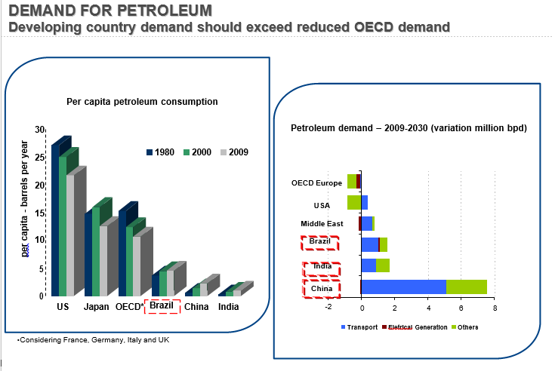

# **Exit Strategies**

A possible outcome is that at the end of the repayment and owner intention holding period, the refinery may be bought in part or full by the any of the major oil companies. Baker Hughes, Schlumberger, Shell, Total and Puma Energy are just a few names that come to mind. Operator or investor interests are a reality as has been the case in Nigeria where Arabian companies have shown interest in the Dangote Refinery.

At the time, dependent factors of valuation will be the company’s combined earnings, asset value, and business goodwill. Timing for M&A activity will depend upon the general health of the energy industry, the outlook for the energy sector at that time, and the state of the general economy.

It is anticipated an M&A opportunity for the company between the end of the 4rd to 5th year of operations. This will be a at the point of full operation, with the general business sector being aware of the existence of the refinery. Most potential partners will be members of the Bulk oil distribution of Ghana who operate generally in the downstream sector. Groups have already shown interest and will collaborate to purchase tankers for lifting in specific and constant quantities.

Profitability will be monitored simply and consistently by utilizing the variable cost method. Once variable costs are covered short or long term, the refiner will be sustainable. A fertilizer company will be contracted to buy the constant supply of the petroleum by product. Fortunately, the transportation business require petroleum lubricants and tyre demand is consistently high.

Fortunately the availability of versatile technology means that the refinery can be constructed in such a way as to convert it into a manufacturing plant when the volume of crude oil drops below economically viable quantities in 60 to 80 years’ time if new deposits are not discovered by then. It is however estimated that the current new deposits together with the current ones will far exceed that timeline.

However, taking a risk averse approach means that a water treatment, fertilizer, LFG, agriculture or LFG plant can be the final form of the refinery if need be.

# **GLOSSARY - TECHNICAL TERMS**

Acronyms & Unique Terms Used in this Business Plan

### Mergers and Acquisitions M&A

### Gas Conversion Company GCC

Gas Liquidfication GL

### Cubic Feet per Day cfd

### Fisher-Tropsch Technology FT

Tema Oil Refinery TOR

Liquefied Natural Gas LNG

Liquefied Petroleum Gas LPG

Compressed Natural Gas CNG

Barrels per day BPD

Million barrels per day MM BPD

Landfill gas LFG

REFERENCES / SOURCES

XXXXXXXXXXXXXXXXXXXXXXX

www.npa.gov.gh

BP statistical Review 2020

canadianenergycentre.ca

WoodMackenzies’ data

IEA 2020, World Energy Investment Report

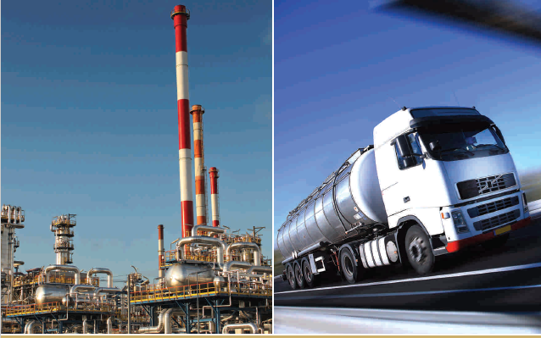

|  |  |
| --- | --- |
| COMPANY NAME | **XXXXXXXXXXXXXXXXX** |
| CONTACTS | XXXXXXXXXXXXX |